**ELECTRONIC AIRLINES DAILY ROUTE RECORD**

**(E-ADR16)**

**Bayode Blessing Akinbola.**

**Table of Content**

i. Introduction. …………………………………………...…. 3

ii. Statement of the problem. ………………………..………. 3

iii. Aim and Objectives. ………..……………………….……. 4

iv. Methodology. …………………………………………..…. 4

v. Implementation. ………………………………..…………. 4

vi. User’s Guide. …………………………………………...… 9

1. **Introduction**

As population increases, traveling rate escalates across the World and the more we keep having Traveling Agencies (both private and Governmental). With respect to this, Statistical analysis to think of.

It is mandatory in Nigerian Airspace Management Agency (NAMA) in each Stations across Nigeria to compile all Air Trasport Operators to render statistical analysis of their operations for the month in a format prescribed by the Authority. Subsequence to this, more hands are needed for collation and analysis of data especially in a very big and busy Stations located in places such as Lagos, Abuja, Kano etc.

In this our generation, Computer Systems had been designed and developed to make works easier and faster with a trusted level of accuracy.

Therefore, Technology quadrantes a higher level of positive impacts in this very operation.

1. **Statements of Problem**
   1. The Statistical Unit in NAMA is aimed to collate and analyze all Air Traffic data for each Airlines /Operators ranging from daily basis to monthly basis as-well-as publishing of Annual Traffic Movements on Passengers and Aircraft based on the Airlines Daily Route Records (ADR16).
   2. However, the System in-use (Manpower) is inefficient due to human-imperfection and time wasting especially in the aspect where large number of traffic is recorded.
   3. Consider an Airline with total traffic of **232 Aircraft movements an 7938 Passenger movement** roughly calculated as **231 Aircraft movements and 7887** resulting to the billing loss of one traffic with **51** Passengers.
   4. Using an **Electronic Airlines Daily Route Record (E-ADR16),** accurate statistical record can be met as-well-as easy Air Traffic Movements Publication.
   5. NAMA stands to benefit more from the adoption of E-ADR16 and will also make NAMA more competitive among other traveling Agencies.
   6. The enhancement of the current System or adoption of E-ADR16 is essential to ensure the advancement of NAMA.
2. **Aim and Objectives**

The aim is to develop a Software for managing Air Traffic Operational Data using NAMA, Ilorin Station as Focus group.

**Objectives**

* 1. To propose an effective System of Managing Air Traffic Operation Data.
  2. To design and implement a Software for Statistics Unit in NAMA.
  3. To evaluate the Software developed.
  4. To fully deploy the Software with the approval of NAMA.

1. **Methodology**

The methodology subsequence to the development of the Software are as follows:

4.1. Collection and understanding data.

4.2. Identifying the relationships between data sets.

4.3. Design of the System’s Graphical User Interface (GUI) with Java programing language using JSWING and AWT.

1. **Implementation**
   1. **Functional Requirements**
      1. Efficient data storage.
      2. Easy correction of data.
      3. Automatic statistical calculation of daily Air Traffic Movements.
      4. Automatic statistical calculation of monthly Air Traffic Movements.
      5. Removal of Airlines without any traffic within the Monthly Reports.
      6. Easier printing function.
      7. Automatic detection of Aircraft’s data with arrival but without departure.
      8. Automatic detection of Aircraft’s data with departure but without arrival.
      9. Easy management of Airline/Operator’s details.
      10. Privilege access control.
      11. Quick sorting of Operator names during operation.
   2. **Usability**
      1. Interactive Graphical User Interface (GUI).
      2. Less cognitive for Computer illiterates and first timers.
      3. Provision of Tools-tips for all components in the Software.
      4. Provision of User’s Guide within the Software.
   3. Designs
      1. **Graphical User Interface (GUI)**

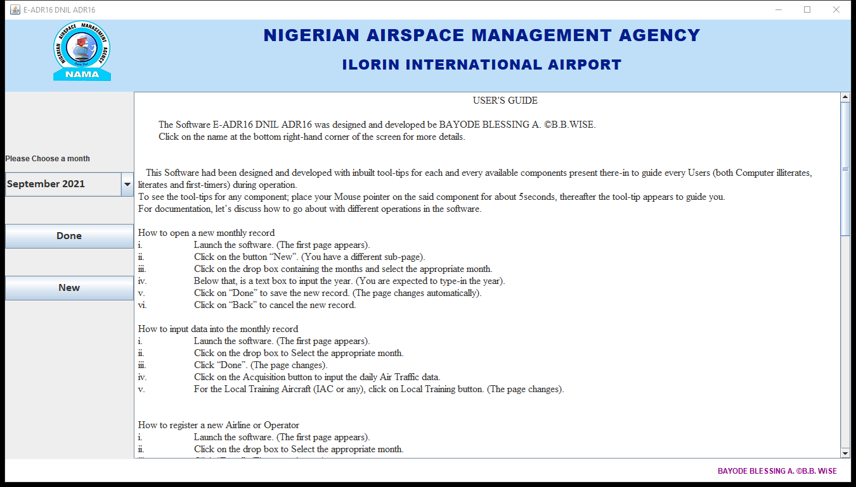

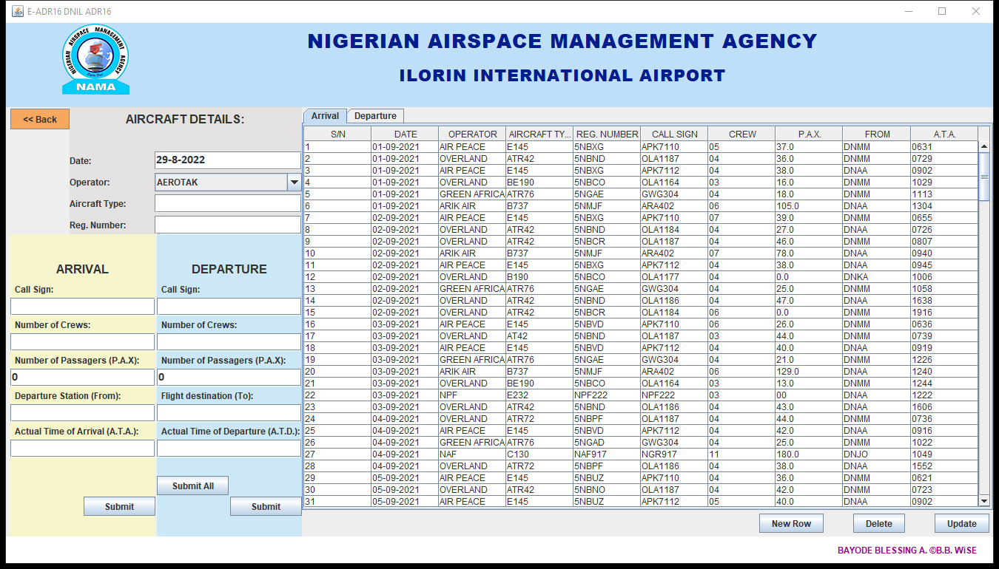

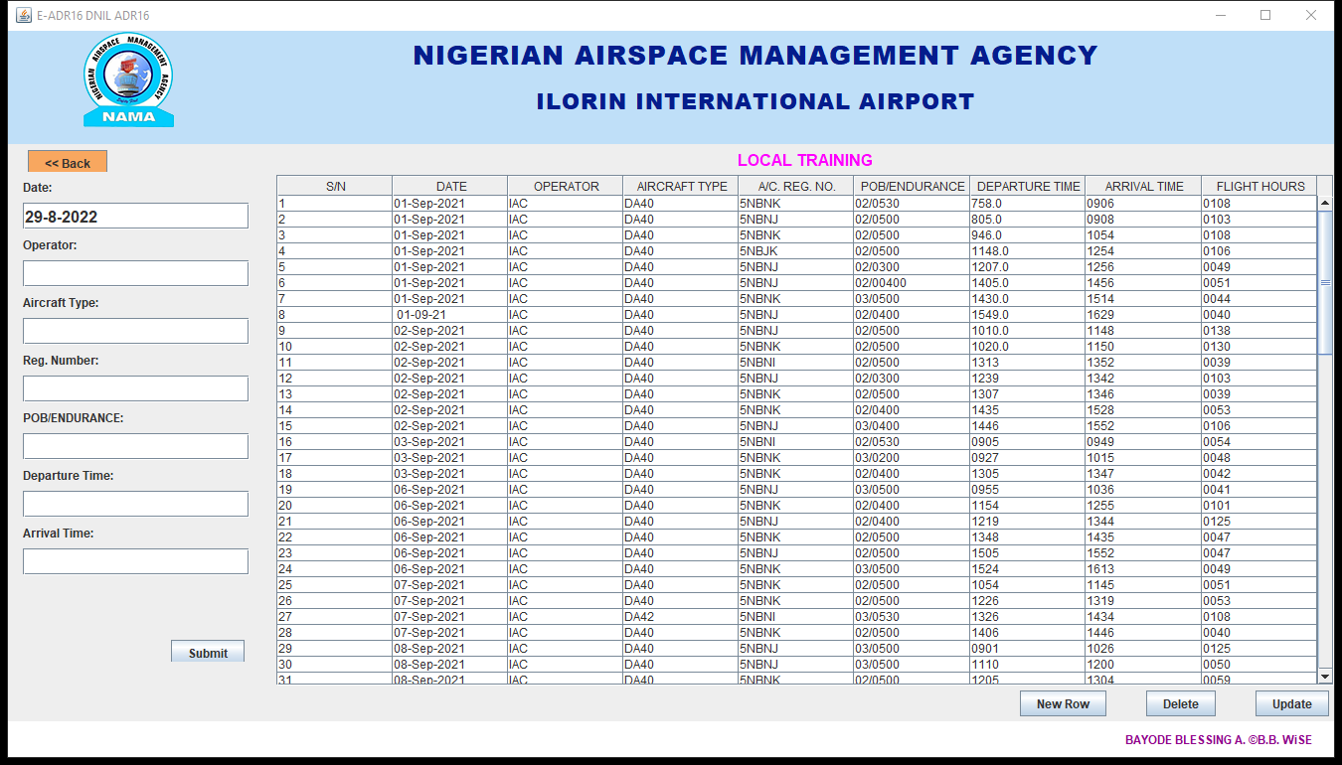

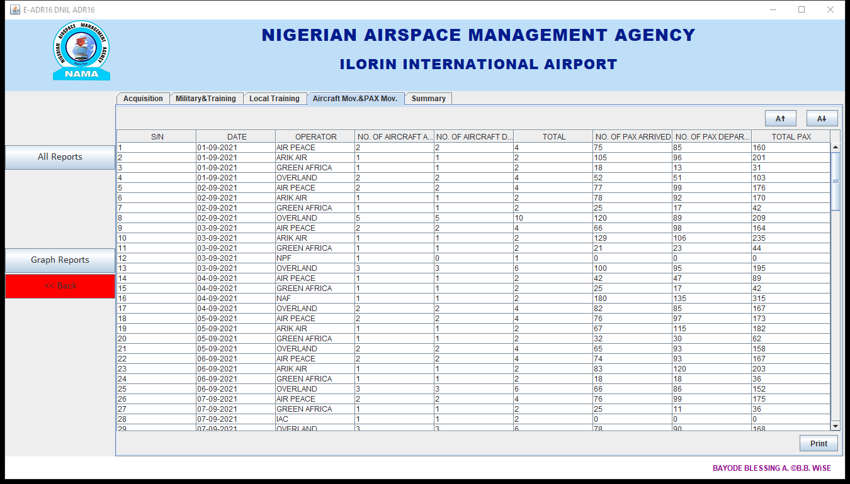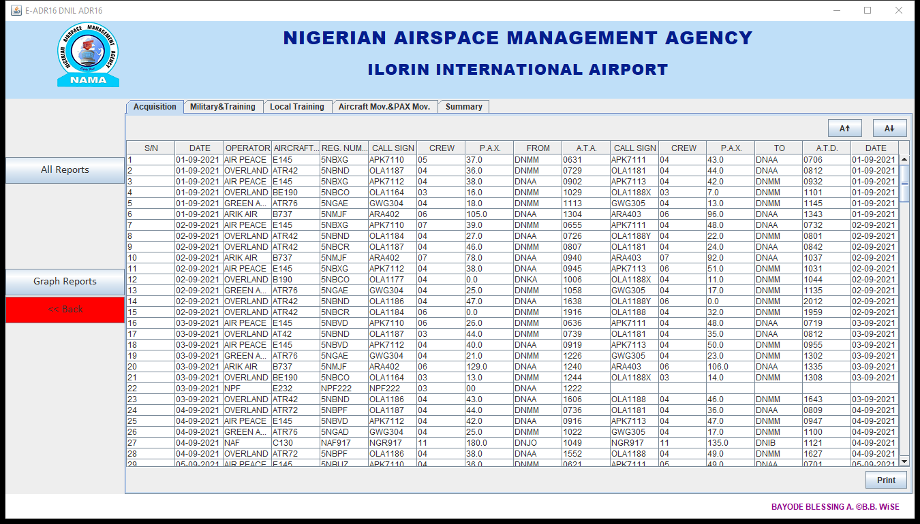

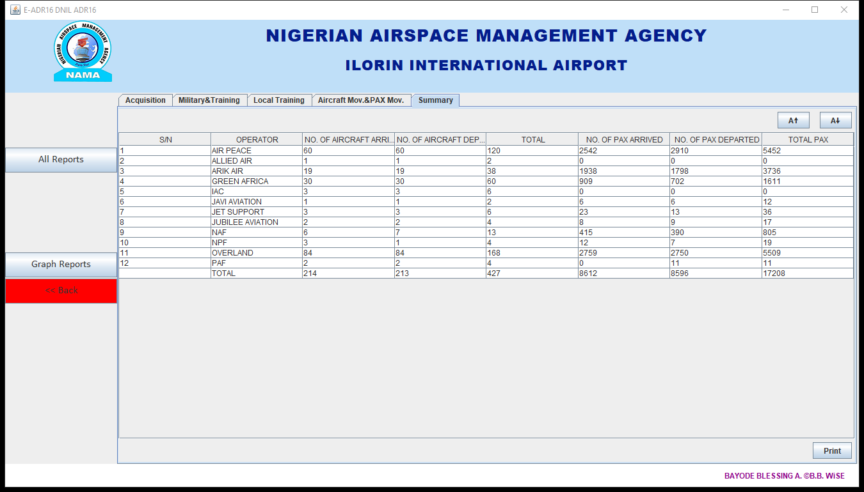

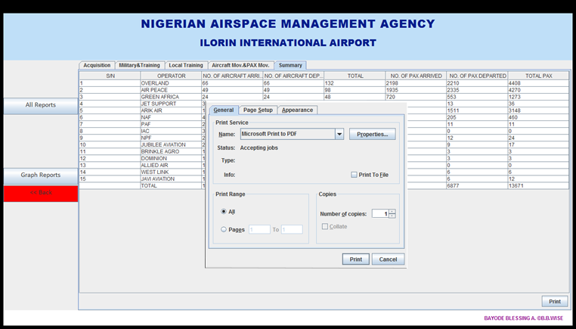

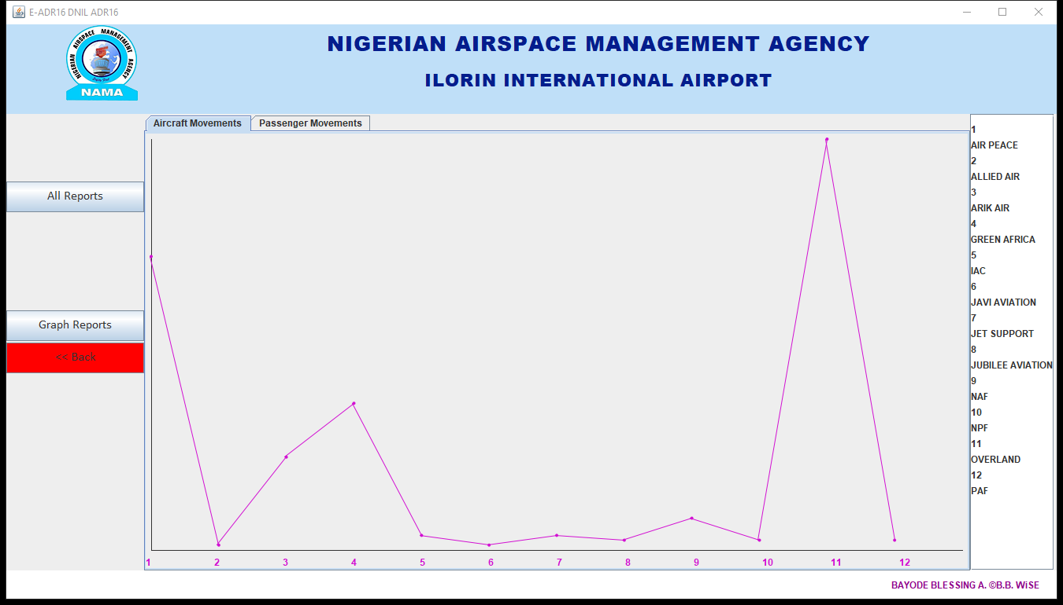

1. **User’s Guide**

This Software had been designed and developed with inbuilt **tool-tips** for each and every available components present there-in to guide every Users (both Computer illiterates, literates and first-timers) during operation.

To see the tool-tips for any component; place your Mouse pointer on the said component for about **5seconds,** thereafter the tool-tip appears to guide you.

For documentation, let’s discuss how to go about with different operations in the software.

* 1. **How to open a new monthly record**

1. **Launch** the software. *(The first page appears)*.
2. Click on the button “**New**”. *(You have a different sub-page).*
3. Click on the drop box containing the months and **select the** **appropriate month**.
4. Below that, is a text box to **input the year**. *(You are expected to type-in the year).*
5. Click on “**Done**” to save the new record. *(The page changes automatically).*
6. Click on “**Back**” to cancel the new record.
   1. **How to input data into the monthly record**
7. **Launch** the software. *(The first page appears).*
8. Click on the drop box to **Select the appropriate month.**
9. Click “**Done**”. *(The page changes).*
10. Click on the **Acquisition button** to input the daily Air Traffic data.
11. For the Local Training Aircraft (IAC or any), **click on Local Training button**. *(The page changes).*
    1. **How to register a new Airline or Operator**
12. **Launch** the software. *(The first page appears).*
13. Click on the drop box to **Select the appropriate month.**
14. Click “**Done**”. *(The page changes).*
15. Click on the button “**New Operator**”.
16. **Type** the name of the new Airline/Operator to the text box available.
17. Below it, is a Check box. This is to be checked (marked) only when the new Airline/Operator is a Military or a Training Airline. *(Please be cautious).*
18. Click on “**Done**” to save the new record. *(The page changes automatically).*
19. Click on “**Back**” to cancel the new record.
    1. **How to view and print the statistical reports**
20. **Launch** the software. *(The first page appears).*
21. Click on the drop box to **Select the appropriate month.**
22. Click “**Done**”. *(The page changes).*
23. Click on the button “**Reports**” and “**All Reports**” thereafter.

*(In this very page there are five different tabs with different contents according to their names;* ***Acquisition, Military/Training, Local Training, Aircraft Moves & Passengers Moves, and Summary;*** *each with different Print buttons (changes in print buttons might not be noticeable).*

1. Click on each “**Print**” buttons in each tab to print the reports. *(Ensure the printer is properly plugged and connected).*
   1. **How to input data in the Acquisition page**
2. **Launch** the software. *(The first page appears).*
3. Click on the drop box to **Select the appropriate month.**
4. Click “**Done**”. *(The page changes).*
5. Click on the button “**Acquisition**”.

*(Type-in the necessary data (details) related to each air traffics as requested from this page).*

1. Click on “**Submit All**” button to submit all typed data to the appropriate tables (Arrival and Departure table).
2. *(In case of only arrival)* Click on the “**Submit**” button under the arrival section to submit all the arrival data (details).
3. *(In case of only departure)* Click on the “**Submit**” button under the departure section to submit all the departure data (details).
   1. **How to correct wrong input(s)**
4. **Launch** the software. *(The first page appears).*
5. Click on the drop box to **Select the appropriate month.**
6. Click “**Done**”. *(The page changes).*
7. Click on the button “**Acquisition**”.
8. **Double click** on the said cell in the table where wrong input is noticed.
9. **Type-in the correct** data.
10. ***Press the “Tab” button on the Computer keyboard.*** *(This is very important).*
11. Click on the “**Update**” button at the bottom right-hand corner of the screen.
    1. **How to delete row(s)**
12. **Launch** the software. *(The first page appears).*
13. Click on the drop box to **Select the appropriate month.**
14. Click “**Done**”. *(The page changes).*
15. Click on the button “**Acquisition**”.
16. **Click** on the said row in the table.
17. Click on the “**Delete**” button at the bottom right-hand corner of the screen.